# input

import matplotlib.pyplot as plt

x=[1,2,3,4,5]

y=[-3,-6,-9,12,15]

plt.plot(x,y)

plt.xlabel("numbers")

plt.ylabel("multiples of 3")

plt.title("multiplication graph")

plt.show()

# out put

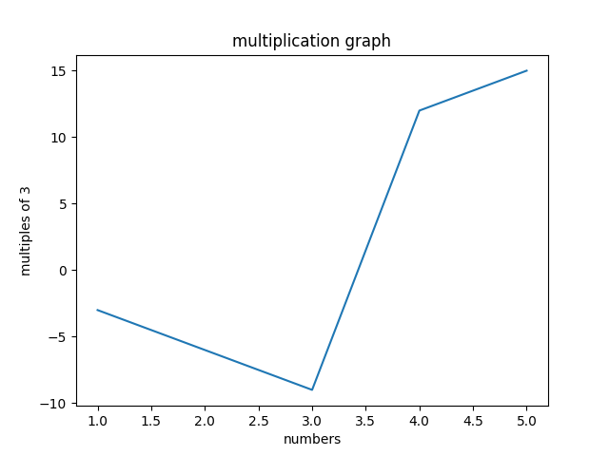

# input

import matplotlib.pyplot as plt

#x-cordinates of left side of bars

left=[1,2,3,4,5,6,7]

#heights of bars

height =[5,10,15,20,25,30,35]

#labels for bars

tick_label =['A','B','C','D','E','F','G']

#plotting a bar chart

plt.bar(left, height, tick_label =tick_label,width=0.7,color=['blue','red'])

#naming the x-axis

plt.xlabel("numbers")

plt.ylabel("multiples of 5")

plt.title("multiplication gragh of 5")

plt.show()

# output

